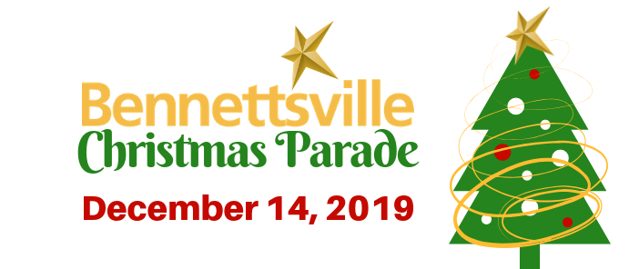
Saturday, Decmber 9th, 2023

Saturday, December 9, 2023 11:00 am
2023 Theme Information & Guide

Theme “Winter Wonderland”

PLEASE NOTE: “Best in Show” winners are heavily based upon originality, overall appearance, quality of workmanship, construction, uniforms or costumes, and holiday spirit for Christmas Parade Float.

General Rules
- No entry may feature a live or life-size Santa Claus.
- All participants (unit members, escorts, staff, etc.) must be in some type of uniform, holiday dress or color coordinated attire.
- Alcoholic beverages and/or controlled substances are forbidden on any float, in any vehicle or on the person of any participant. Participants consuming alcohol/drugs prior to or during the parade will be removed from the line-up, subject to arrest, and will not be allowed to participant in any future parades. No refunds will be given.
- It is unlawful to throw ANYTHING from any moving entry, including candy. This rule must and will be enforced for the safety of small children who might be tempted to run out into the street. Any participant caught throwing anything from their entry will be immediately removed from the parade and disqualified. Note: You may have walkers with your float to hand out candy, items, etc. to parade attendees, but please do not throw anything.
- No one is allowed on or off moving floats. Staff or escort changes should only be made when the float has come to a complete stop. (Exception: Emergency)
- All units must remain in their assigned position throughout the parade.
- Any and all music MUST BE themed and family friendly.
Parade Line-Up
- Entries may begin lining up at 10:00 a.m. No one will be allowed to begin lining up until after streets have been closed at 10:00 a.m. in order to ensure the safety of participants.
- All participants (float riders, escorts, staff, walking units, band members, etc.) with your entry must arrive and be in place before 11:00 a.m.
- No one will be admitted to the staging area after 11:00 a.m. This will be strictly enforced.

Vehicles
- All tow vehicles must be decorated and incorporated into the individual float theme which should be in accordance with the overall parade theme.
- Parade organizers encourage businesses and organizations to explore sponsoring and/or partnering with civic organizations that may need assistance with their parade entry.
- Flatbed trucks may be used in place of a trailer. The bed of the truck should be decorated according to float decorating specifications (see FLOATS).
- The blowing of sirens or vehicle horns at any time during the line-up phase or during the parade is prohibited.
- Pageant winners must be 13 years old or older to ride on top of a vehicle. If they are under 13, they must have an adult riding on top of the car with them.
- Drivers of motorized vehicles must be at least 18 years of age and have a valid driver’s license.
Bands, Performing Groups, Walkers & Marching Unit
- All walkers must be in uniform, holiday dress or color coordinated attire. Dress for walkers (staff and/or escorts) escorting floats should coordinate with the individual float theme which should be in accordance with the overall parade theme.
- Walking units not associated with a float must carry a sign/banner with their organization name at the front of their unit.
- No entries, in the performance of drills or other display, shall cause any delay in the parade.
- Performances are limited to 45 seconds. VERY IMPORTANT: Any group whose performance lasts longer than 45 seconds WILL be disqualified.
- Stationary performances are only allowed for the judges. All other performing should be conducted while moving in a forward motion.
- Judges will be located on the lawn of the Marlboro County Courthouse.
Floats
- Floats must be a fully decorated trailer, flatbed truck, or other platform on wheels that is self-propelled or pulled by a tow vehicle. All floats MUST be decorated in a Christmas theme.
- Floats must not exceed a height of 14 feet.
- All floats must display a sign/banner with their organization name on BOTH sides of the entry.
- Adult supervision is required for any riders under 13 years of age.
Awards
- A cash prize of $300 and a trophy will be awarded to:
  - Best of Parade
  - Creativity (Most creative)
  - Illumination (Float with the best display of lights)
- Trophies will be awarded in each of the following categories. (Note: 1 winner per category):
  - Commercial Businesses
  - Non-Profit/Religious/Government
  - Education/Schools (floats and vehicles decorated by any school (pre-school – college)
  - Performing Groups (dance groups, cheerleaders, marching bands, etc.)
- NOTE: Unless otherwise determined by the City of Bennettsville Department of Tourism, Parks & Recreation, you will be scored in the category selected on your application.
- Please select only ONE category.
For additional information: Jaharra.graves@bennettsvillesc.com or 843-479-3941

Mail or Hand Deliver Application & Payment to:
City of Bennettsville
Department of Tourism, Parks & Recreation
PO Box 1036
Bennettsville, SC 29512
Parade Entry Fee: $25.00
*Payable by Cash, Check or Money Order

**In the event of inclement weather, no monies will be refunded**

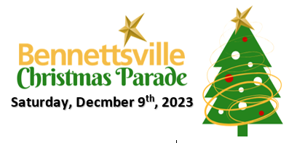

2023 City of Bennettsville Christmas Parade Application

Entry Name: This name should be used on the required signs/banners. It is YOUR RESPONSIBILITY to inform all members of your group of your official entry name, number, line-up instructions and rules. You must complete a separate entry form for each group within organization. Example: Cheerleaders will need separate entry form from football team and marching band. If separate applications are not completed for each entry, your entry will only be judged one time. PLEASE COMPLETE EVERY BLANK ON THE APPLICATION (include n/a if necessary).

Name of Organization _______________________________ Contact Name ___________________________________
Mailing Address _________________________ City_____________________________ State ____ Zip ____________
Best Contact # _________________________ Email ___________________________________________________

The following information is necessary to allow ample room for entry placement. Please complete the following and add any additional information you feel is important for proper spacing and placement of your entry.

Total Length of Float (include both the float and the vehicle pulling float): _____________________________________

Walkers: Yes or No If yes, how many?___________

Detailed description of your organization and float (including if you will have music).
_________________________________________________________________________________________________
_________________________________________________________________________________________________
_________________________________________________________________________________________________

Commercial Business Non-Profit/Religious/Government
Performing Groups Education/Schools

Important: The entry form and fee must be completed, signed, and received by December 1st. If you have questions concerning the rules and guidelines, please call the Tourism, Parks & Recreation office at 843-479-3941 for further clarification. Applications WILL NOT be accepted after December 1st. This deadline must be adhered to in order to establish the line-up and inform participants in a timely manner.

Waiver: In consideration of accepting this entry, I, the undersigned, have read and agree to abide by the rules and regulations in the City of Bennettsville 2023 Christmas Parade Guide. Furthermore, I hereby grant full permission to the City of Bennettsville and/or any agents authorized by them to use any photographs, videotapes, motion pictures, recordings, or other record of this event for any legitimate purpose. My signature below indicates that I understand I am personally responsible for my actions before, during and after the parade. I will not hold the City of Bennettsville, the Department of Tourism, Parks & Recreation, or any sponsor/volunteer involved in the parade liable for my participation or actions.

Signature: ________________________________________ Date: _____________________________

